An Integral Ecology

Message VIII International Mission Commission
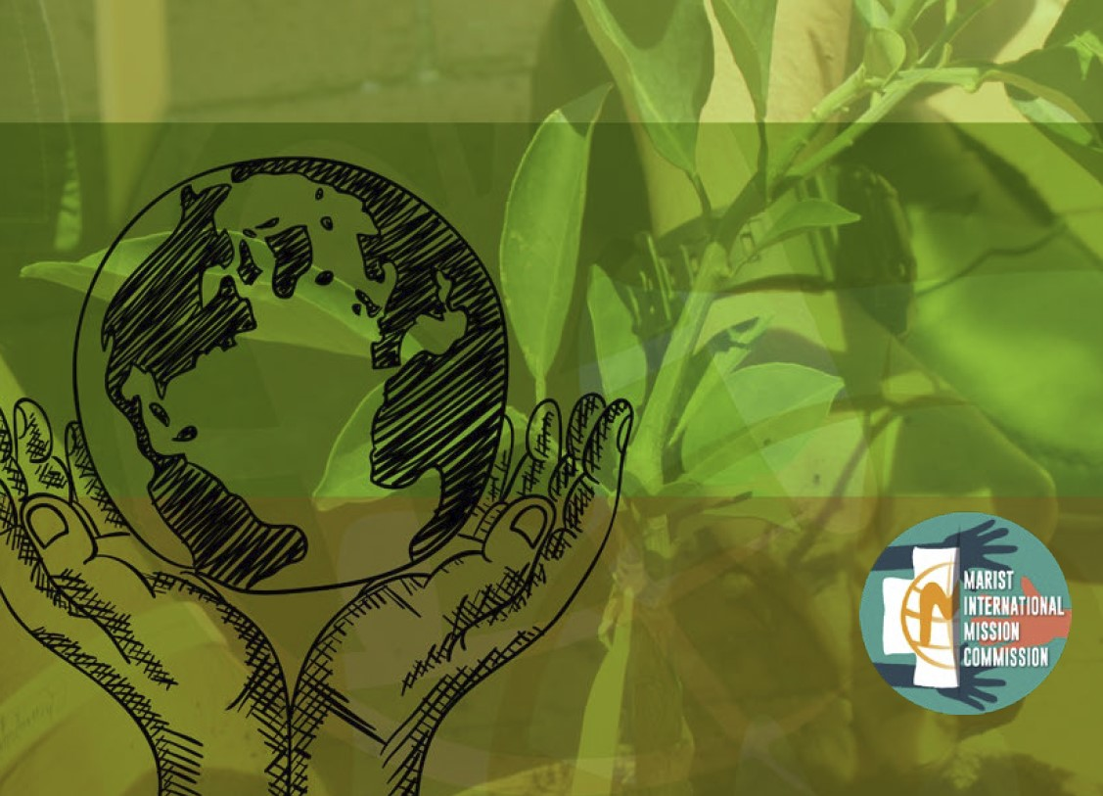

Link to Message VIII https://champagnat.org/en/an-integral-ecology-message-from-the-marist-international-mission-commission/

An Integral Ecology – Selected paragraphs

In many circles, fortunately, we can perceive an increasing sensitivity to the theme of ecology. We unite ourselves with the approach which Pope Francis proposes in the encyclical Laudato Si, called an “integral ecology”, which incorporates both human and social dimensions. Care for life cannot separate human beings from the way in which they live, given that both realities
are related and mutually enrich and help each other.

Our participation in groups of reflection, in networks and organisations with a clear ecological outlook, community and provincial proposals, participation in conferences are some ways to grow in this area. There are an increasing number of local, national and international calls for
the care of our common home which demonstrate a growing interest to incorporate the integral ecological perspective into our daily life.

Our world, becoming ever more a global culture, calls to us to collaborate with others, to participate and propose points for reflection and action. One of the activities is participation in networks to defend our common home. These networks allow us to create the “critical mass”, that is to say, a significant group of people who help us to change the way we understand our
relationship with nature and the implications that this has for us.

Following the path of integral ecology presents some major challenges to us as Christians and Marists of Champagnat. Marcellin knew how to confront the great challenges which he met in his own time and his own society. We too are called to respond to the emerging needs of our own world. As the XXII General Chapter reminds us, we are already taking steps which will
lead us to a meaningful and audacious response.
- Care for our common home
- Care for people, particularly those who are most vulnerable
- Care for education
- Caring for the future, without forgetting the present

Prayer

Loving God, You call us to love,
a most fragile and precious action.
You challenge us to love unconditionally as You love.
Even when we fail to love others as you love us
You encourage us to extend a welcome to others.

In Mary, You give us an example of someone who was prepared
to go the extra mile when her cousin Elizabeth was in need.

In Marcellin Champagnat, You give us an example of someone
who seeing the desperate needs of his time responded to the challenge.

Marcellin was aware that each child needed to be loved.
He realised the importance of accepting each person
and allowing them to develop into who
You intended them to become.

May we accept the challenge before us,
to strengthen the Family Spirit in this school. Amen.

Mary, our Good Mother, pray for us.
St Joseph, pray for us.
St Marcellin Champagnat, pray for us.

Champagnat Marist Spirituality and Charism:
God’s Presence and Love Trust in God Love of Jesus and His Gospel
Presence Simplicity Family Spirit Love of Work
In the Way of Mary

