Spirituality in Mission
and Mission in Spirituality

Message XIX International Mission Commission

Link to Message XIX https://champagnat.org/en/spirituality-in-mission-xix-marist-international-mission-commission/
Spirituality in Mission and Mission in Spirituality – Selected paragraphs

There are many conceptions of spirituality. In our case, spirituality is intimately connected with our Christian and Marist tradition. We find the meaning and explanation of our existence in the reference to and the experience of the living person of Jesus Christ and his Gospel, and from Mary’s inspiration.

Indeed, spirituality is a universal human experience that involves the recognition of a feeling or belief that there is “something” greater than ourselves. It is an experience that often involves a search for meaning or purpose in life. In other words, spirituality involves knowing that our lives have meaning in a context beyond ordinary everyday existence. And this is what saints and spiritual masters have come to remind us: that we are much more than our tangible bodies.
Spirituality speaks to us of life, integration and perspectives. Spirituality is not fundamentally a space of dogmas but of experiences, of “come and see” (Jn 1:43-51), of wonder and awe (John 1:35-42), of stillness and following (Jn 14:1-14), of passion and action (Mk 1:14-20), of tenderness and mercy (Mt 9:35-36), of contemplation of the Father (Mt 5:43-48), of transformation and metanoia (Mt 5:43-48), of fullness and Kingdom (Mt 25:34-40), until we reach the mystical experience and unity contained in Jesus’ desire: “that they all may be one; as you, O Father, are in me, and I in you, that they also may be one in us” (John 17:21-23). Spirituality is intuitive and allows us to see and feel God’s action, his presence and his Spirit at work in all things, in our midst.

Mission and spirituality are two powerful arms of our Marist way. They are also two great challenges. Responses to today’s world cannot be made without a deep commitment in fidelity to the voice of the Spirit. We are an apostolic Institute. We seek to facilitate an encounter with God and with the Gospel, especially on the part of children and young people. We are convinced that this encounter is transformative and prophetic, meaningful and liberating. We are therefore committed to building bridges between them and the heart of our good God. Daringly, we try to ensure that our mission is a living spirituality and that our spirituality is a mission without frontiers.
A Christmas Carol Poem - Gilbert Keith Chesterton, 1874-1936

The Christ-child lay on Mary's lap,
His hair was like a light.
(O weary, weary were the world,
But here is all aright.)

The Christ-child lay on Mary's breast
His hair was like a star.
(O stern and cunning are the kings,
But here the true hearts are.)

The Christ-child lay on Mary's heart,
His hair was like a fire.
(O weary, weary is the world,
But here the world's desire.)

The Christ-child stood on Mary's knee,
His hair was like a crown,
And all the flowers looked up at Him,
And all the stars looked down.

Mary, our Good Mother, pray for us.

St Marcellin Champagnat, pray for us.

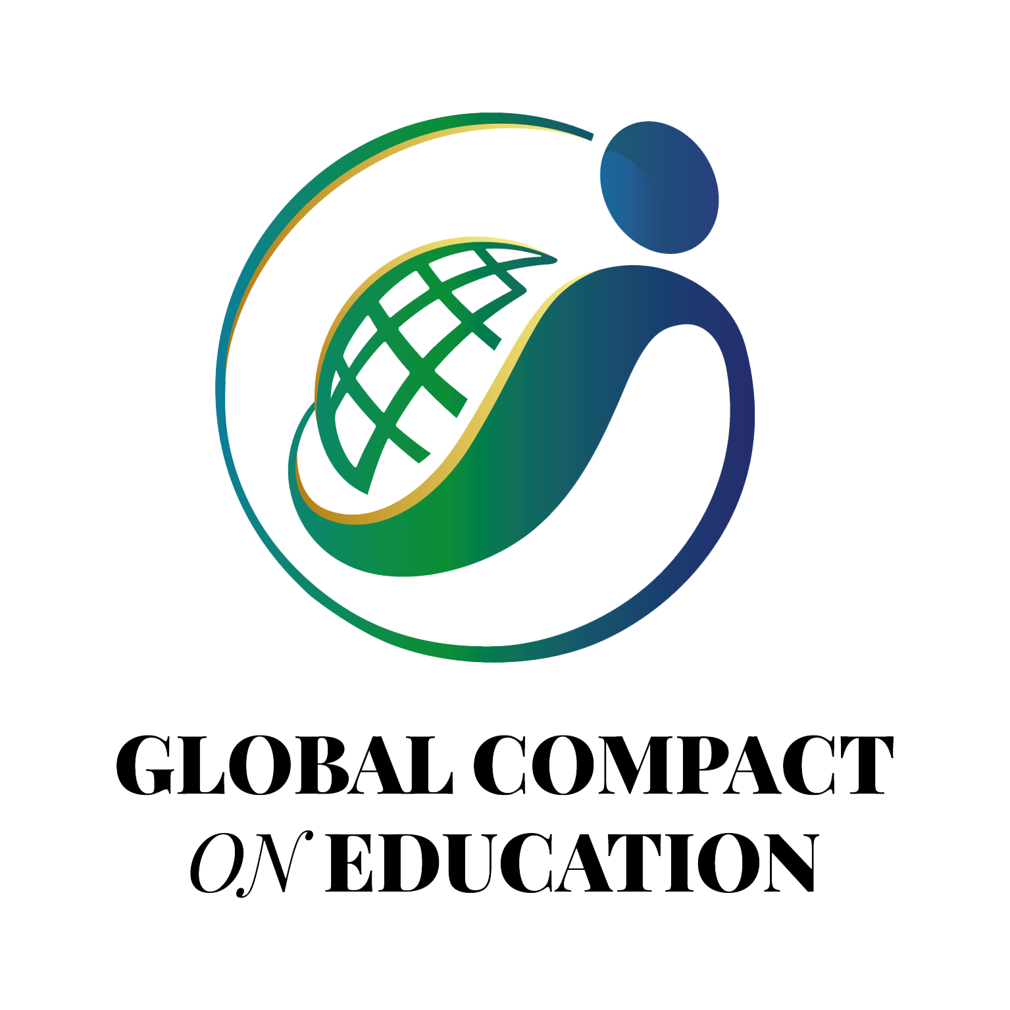

Champagnat Marist Spirituality and Charism:
God’s Presence and Love Trust in God Love of Jesus and His Gospel
Presence Simplicity Family Spirit Love of Work
In the Way of Mary

