FIJI

Marist Insertion Mission Experience
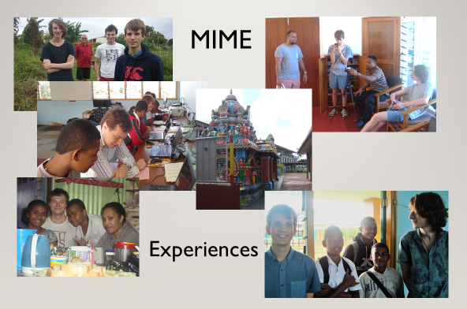
An experience of Marist mission based in Suva, Fiji. The experience includes living in a Marist community, two nights in a family home in a housing development in an outer suburb of Suva, assisting in a school for those who don't fit the conventional classroom, visits with input into a temple and a mosque, and visiting the Marist centre at Lomeri. It is limited to six people. You will be accompanied throughout, and an important part of the experience is self-reflection.

Champagnat Institute
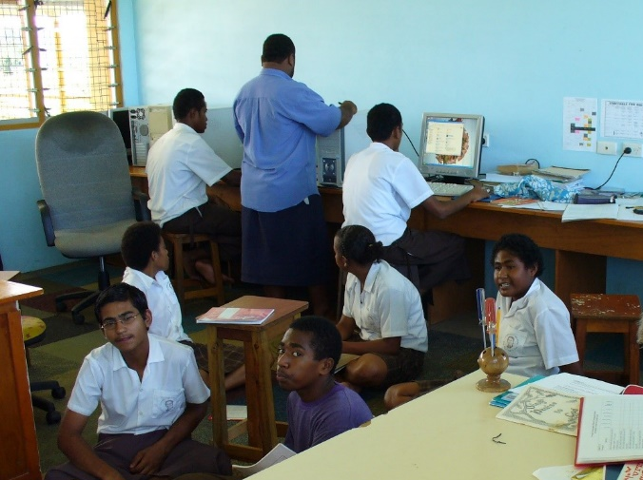
The Champagnat Institute in Suva, Fiji, educates students who are not suited for mainstream schools, including children with disabilities who now have access to vocational education at the Institute.

It is a secondary school where disabled students learn side by side with non-disabled students. There are about 120 students from various backgrounds, but most have started life with a significant disadvantage due to either health, social or economic factors. Volunteers can assist students with developing vocational skills and literacy.

