CALLED AND COMMITTED TO
WORK TOGETHER AS A NETWORK

Message V International Mission Commission
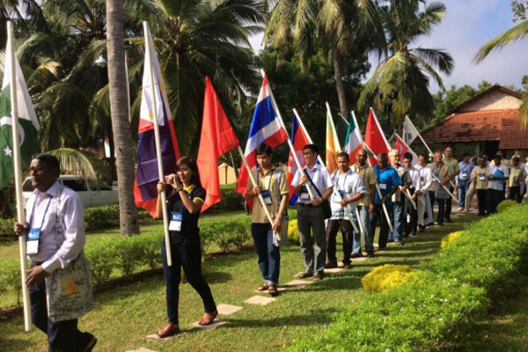

Link to Message V https://champagnat.org/en/v-message-from-the-international-commission-for-marist-mission/

Called & Committed to Work Together as a Network - Selected paragraphs

Just as the virus puts the lives and health of those it attacks at serious risk, in a similar way we are facing situations that threaten the existence of the Marist mission. The continuing decline in the number of brothers, the fragility of some processes of co-responsibility with our lay partners, the weakening of our educational leadership, the crisis of credibility caused by recent scandals in the Church and the erosion of relations with governments are, among others, events that put the viability of the Marist apostolic
mission at risk.

For this reason, we are convinced that overcoming the challenges that face the Institute requires wide-reaching responses with global consequences. We make our own the words of Pope Francis when he affirms that “we need to develop the awareness that nowadays we are either all saved together, or no one is saved”. (Fratelli Tutti, 137)

There is an urgent need to begin a new era based on knowledge, cooperation, interaction, and joint action, more solid and coordinated than ever before. Faced with the challenges to the Marist mission and the consequences of the pandemic, we reiterate the call to actively move ahead following the orientation given by the 22nd General Chapter to “build Marist mission networks at the level of the administrative units, regions and the general administration, which favour innovation and the renewal of our education and evangelization”.

Strengthening our networking will involve changes in thinking and in the way of doing things. Global challenges demand global responses. The networks can take advantage of our great diversity as well as help manage its complexity.

Prayer

God of mystery and new beginnings,
you challenge us to go in haste to a new land.

Like Abraham, our father in faith,
may we journey into the unknown with confidence.

May your Holy Spirit continue to:
Renew our vision.
Guide our deliberations.
Challenge our thinking.
And enable our actions.

Continue to lead us,
so that we may carry your Word of hope and be
messengers of your love and peace in our places of work,
our homes and our communities.
We make this prayer in the name of Jesus. Amen.

Mary, our Good Mother, pray for us.
St Joseph, pray for us.
St Marcellin Champagnat, pray for us.

Champagnat Marist Spirituality and Charism:
God’s Presence and Love Trust in God Love of Jesus and His Gospel
Presence Simplicity Family Spirit Love of Work
In the Way of Mary

